MEMO

TO : Café Stakoverflow Employees

FROM : Rahmat Pratama

CC : Rahmat Pratama

DATE : Mar 26th 2020

RE : Café Rentals

Facebook CEO Mark Zuckerberg wants to rent this café for a day starting Mar 28th 2020, to have a meeting with Microsoft CEO Bilgates.

Thanks you for your cooperation.

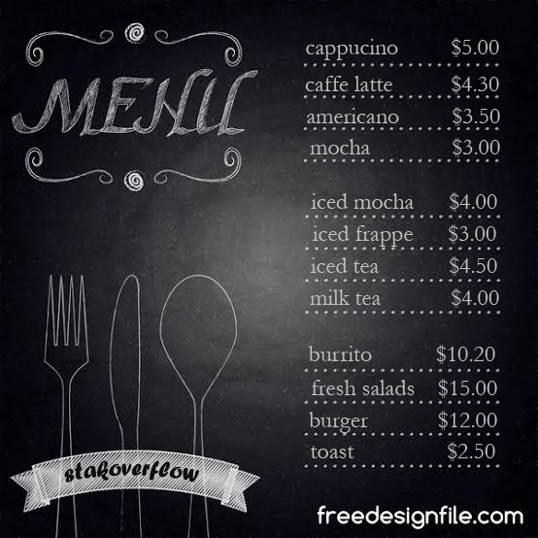

Open 15:00 wib

CEO : Rahmat Pratama

|  |  |  |
| --- | --- | --- |
| **Employee name** | **Duty** | **Working time** |
| **firdaus** | **service** | 15:00 – 23:00 wib |
| **ilas** | **Service** | 15:00 – 23:00 wib |
| **mipta** | **Cashier** | 15:00 – 23:00 wib |
| **akmal** | **chef** | 15:00 – 23:00 wib |